**GTU Department of Computer Engineering**

**CSE 222/505 - Spring 2021**

**Homework 2 Report**

**Part 1:**

1. Searching a product.

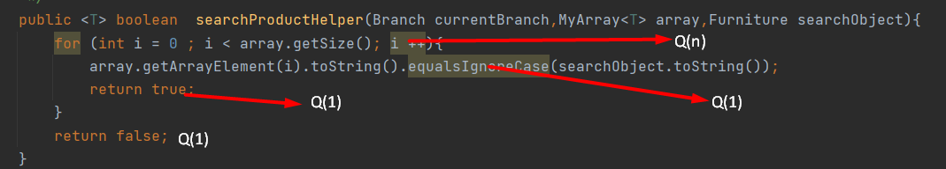

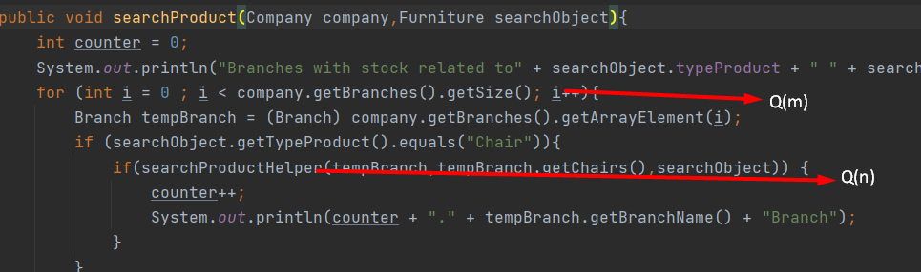

,II.Add/remove product.

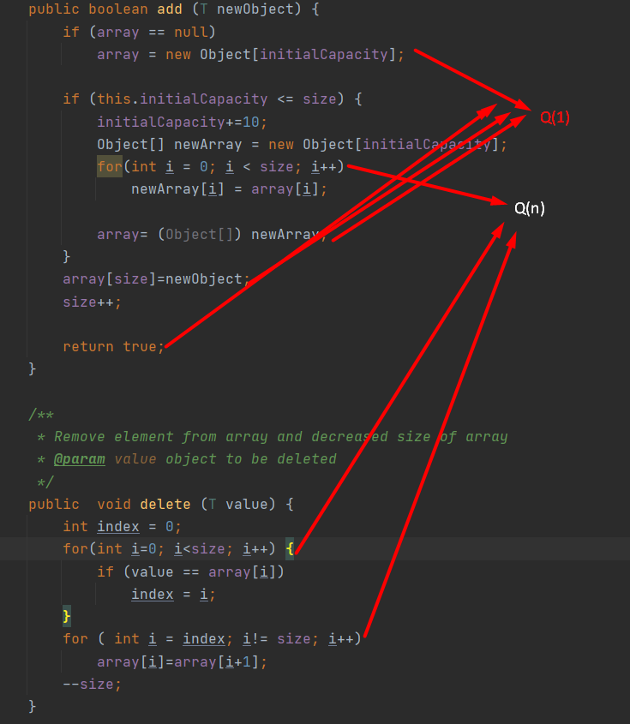



**Part 2:**

1. Explain why it is meaningless to say: “The running time of algorithm A is at least O(n2)”.

Solution:

It is meaningless because;

O(n2) = It is a worst case scenerio of running time so running time of algorithm A will be n2 or faster.But algoritm A could be anything that is smaller.Example:Constant 1 or n…

So there is no information about the lower bound of an algorithm and lower bound without upper bound isn’t useful .

1. Let f(n) and g(n) be non-decreasing and non-negative functions. Prove or disprove that: max(f (n), g(n)) = Θ(f(n) + g(n)).

Solution:

f(n) ≤ max(f (n), g(n))

g(n) ≤ max(f (n), g(n))

f(n) + g(n) ≤ 2max(f (n), g(n))

* ½ (f(n) + g(n)) ≤ max(f (n), g(n))
* max(f (n), g(n)) ≤ 1(f(n) + g(n))

So c1 (f(n)+g(n)) ≤ max (f(n),g(n)) ≤c2(f(n)+g(n)) for n > *n*0 => c1 = ½ c2 = 1

it holds true for c1 = ½ and c2 = 1

1. Are the following true? Prove your answer.
   1. 2n+1 = Θ(2n)
   2. 22n = Θ(2n)
   3. Let f(n)=O(n2) and g(n)= Θ(n2). Prove or disprove that: f(n) * g(n) = Θ(n4).

Solution:



**Part 3:**

List the following functions according to their order of growth by explaining your assertions.

n1.01, nlog2n, 2n, √n, (log n)3,n2n, 3n,2n+1, 5 log2 n, logn

Solution:



**Part 4:**

Give the pseudo-code for each of the following operations for an array list that has n elements and analyze the time complexity:

* Find the minimum-valued item.
* Find the median item. Consider each element one by one and check whether it is the median.
* Find two elements whose sum is equal to a given value
* Assume there are two ordered array list of n elements. Merge these two lists to get a single list in increasing order.

Solution:





**Part 5:**



